COCA-COLA – “PUBLIX DROID ADVENTURE”

Client: Michael Pelletier
Writer: Matthew Montemaro
Date: 4/25/25
Version: 2
“Publix Droid Adventure”
Concept: Coca-Cola and Disney bring "Real Magic" to Publix shoppers through an immersive Star Wars-themed experience featuring an interactive Coca-Cola Droid.

AUDIO | VISUALS
(SFX)  Droid lights up subtly; sounds start.  Futuristic hums, soft droid beeps.  NARRATOR VO:  "What if every trip to Publix could feel like stepping into a galaxy far, far away?" | Publix storefront with Coca-Cola Star Wars Droid Display.  We see families entering the store.  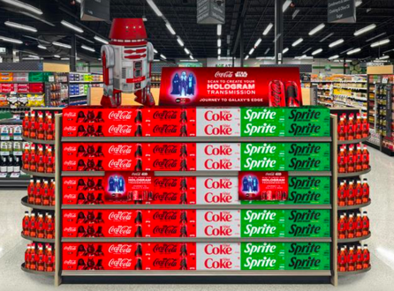  GFX: Text overlay: “Coca-Cola and Disney bring Real Magic to Publix.”
(SFX)  Happy droid chirps  NARRATOR VO  "Now greeting shoppers at the front of every Publix... a one-of-a-kind Droid display that lights up, interacts, and engages." | Emma walks inside with a Publix basket.  Droid greets her with lights and sound. (CU of droid waving)  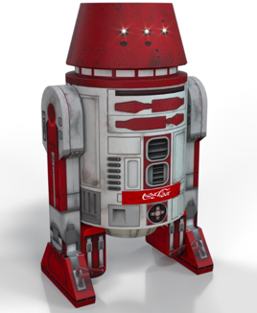  Wide shot reveals other guests scanning the QR code, kids posing for photos, and others grabbing 12-packs.  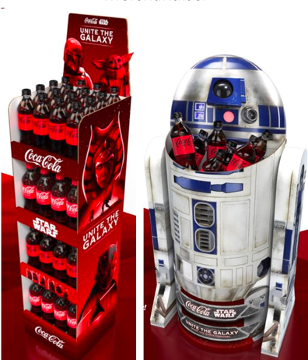
NARRATOR VO:  "Shoppers can record and send custom holograms, creating magical Star Wars moments to share with friends and family.”  (SFX)  Sci-fi hologram buzz. | Emma taps the screen and records: "Hey guys, we’re all going to Galaxy’s Edge!"  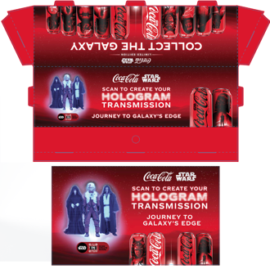  (GFX)  Shimmering blue projection effect of hologram.
(SFX)  Celebratory ding; subtle Star Wars-themed score.  NARRATOR VO:  "With each visit, shoppers can unlock exclusive ticket packages to Disney Parks... including Galaxy’s Edge." | Screen shows Exclusive Disney Parks Offers in front of Emma in store from the hologram.    Screen animates to display ticket deals. Emma taps Buy Tickets. Emma smiles.  We see Galaxy’s Edge assets on screen.
NARRATOR VO:  "An unforgettable experience that delights shoppers, drives traffic, and builds excitement — "It starts with a trip to Publix... and ends in a galaxy far, far away.”  (SFX)  Lightsaber swoosh, crowd cheer. | Show user experience: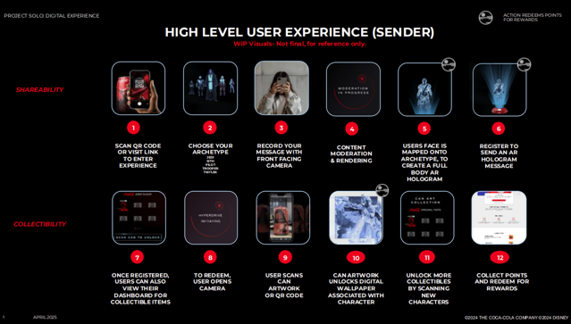  Emma smiling in store, sips a Coca-Cola, as we transition to Emma and three friends now at Galaxy’s Edge — laughing, dressed in full Star Wars attire.
NARRATOR VO:  "For store managers, this activation drives front-of-store engagement, merchandise lift, and repeat traffic thanks to a fun digital treasure hunt experience."  NARRATOR VO:  "Coca-Cola and Disney invite every shopper to experience the Real Magic. Only at Publix."  SFX: Star Wars orchestral finale. | Transition back to store:  Store manager enters back at Publix, proudly watches guests interact with Droid. Visuals of 12-pack lift and QR scans.  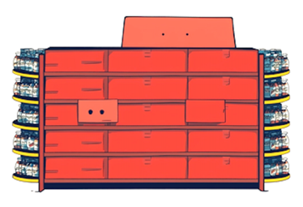  Infographic shows opportunities for store managers.  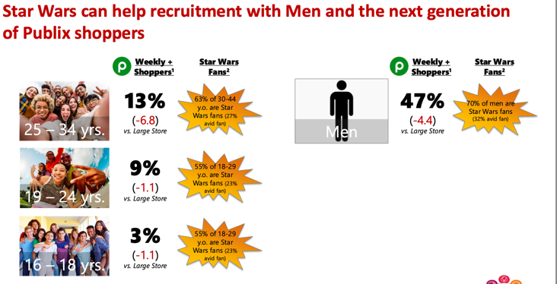  As we exit, Publix feels lively; kids wave at the Droid; we see joyful shopper moments.  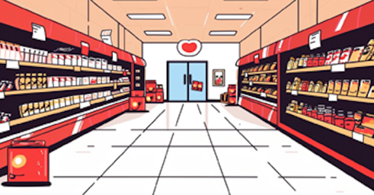  GFX: Coca-Cola + Disney + Publix logos fade up with CTA, "Drive front-of-store excitement. Activate your Droid display today."  Optional: QR code for store managers to access materials.

